Unit-1
- Find the resultant of the force acting on a particle P shown in figure
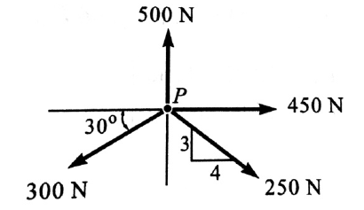
- A system of four forces acting on a body is shown in figure. Determine the resultant force and its direction
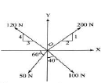
- Explain the procedure to find the resultant of parallel forces

- A 675 N man stands on the middle rung of a 225 N ladder, as shown in figure 1. Assuming a smooth wall at B and a stop at A to prevent slipping, find the reactions at A and B.
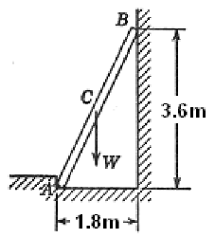
- Two forces equal to 2P and P respectively act on a particle. If first be doubled and the second increased by 12N the direction of the resultant is unaltered, find the value of ‘P’?
- Two smooth spheres, each of radius r and weight Q, rest in a horizontal channel having vertical walls, the distance between which is ‘b’. Find the pressures exerted on the walls and floor at the points of contact A, B and D. The following numerical data are given: r = 25 cm. b = 90 cm. Q = 100 N. as shown in figure 1.
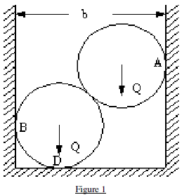
- Explain how will you reduce the system of coplanar, non-concurrent forces to a force and a couple
- A right circular roller of weight W rests on a smooth horizontal plane and is held in position by an inclined bar AC as shown in figure 2. Find the tension S in the bar AC and the vertical reaction Rb at B if there is also a horizontal force P acting at C.
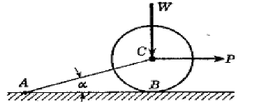
- Three collinear horizontal forces of magnitude 300N, 100N and 250N are acting on rigid body. Determine the resultant of the forces when (i) All the forces are acting in the same direction; (ii) the force 100N acts in the opposite direction

- Show that the algebraic sum of the resolved parts of a number of forces in a given direction is equal to the resolved part of their resultant in the same direction
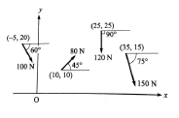

- What do you understand by the term ‘Couple’? Discuss the characteristics of a couple.

- Three concurrent forces have magnitudes of 80 N, 120 N and 100 N respectively.

- Determine the resultant of the force system shown in the figure. Assume that the coordinates of different points are in meters

- A 100kg box is shifted by two persons, one pulling it exerting a force of 200N inclined at 200 to the horizontal and another pushing it from behind by exerting a force of 150N inclined at 100 to the horizontal. Determine the resultant force acting on the box. Refer figure.
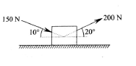
- The resultant of two forces acting at a point is 75.71kN, where one force is double that of the other and if the direction of one is reversed, the resultant becomes 57.17kN. Find the magnitudes of two forces and the angle between them
- Replace the system of forces and couple shown in figure by a single force couple system at A
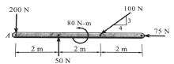
- Figure shows two vertical forces and a couple of moment 2000 N-m acting on a horizontal rod which is fixed at end A. Determine the resultant of the system.
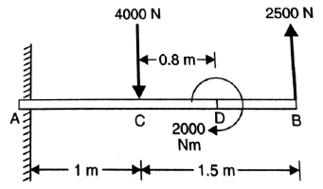

- Write the equilibrium equations for concurrent force system in space
- Three concurrent forces are acting on a body which is in equilibrium, then the resultant of the two forces should be equal and opposite to the third force. Prove this statement..
- Explain the graphical method for finding the resultant of coplanar concurrent force system
- Block P of mass 5kg and block Q of mass m kg, suspended through a cord, are in the equilibrium position as shown in figure. Determine the mass m.
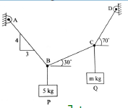
- A 10 m boom supports a load of 600 kg, as shown in the figure. The cable BC is horizontal and 5m long. Determine the forces in the boom and the cable.
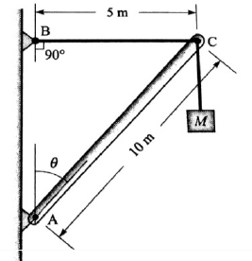
- Find the least horizontal force ‘P’ to start motion of any part of the system of three blocks resting upon one another as shown in figure 3. The weights of the blocks are A = 3000N, B = 1000N, C = 2000N. Between A and B, μ= 0.3, between B and C, μ = 0.2 and between C and the ground μ = 0.1.
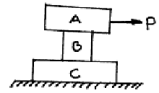
- Two spheres each of 1000N and of radius 25cm rest in a horizontal channel of width 90cm as shown in figure. Find the reaction at the point of contact A, B and C..
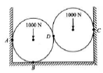
- 20 kg homogeneous smooth sphere rests on two inclined planes as shown in figure. Determine the contact forces at A and B.
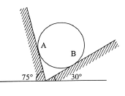

Unit-2

- A block overlying a 100 wedge on a horizontal floor and leaning against a vertical wall and weighing 1500N is to be raised by applying a horizontal force to the wedge. Assuming the coefficient of friction to be 0.3, determine the minimum horizontal force to be applied to raise the block as shown in the figure 2.
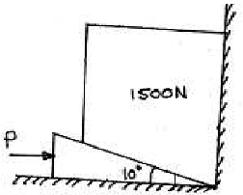

- In figure, determine the horizontal force P applied to the lower block to just pull it to the right. The coefficient of friction between the blocks is 0.2 and that between the lower block and the plane is 0.25. Assume the pulley be frictionless
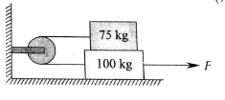

- A cylinder of radius 10cm and weight 20N, resting on an inclined plane, has a flexible string wrapped around it. The string does not slip over the cylinder, and is pulled by weight W to support the cylinder as shown in figure. If there is impending slippage, what is the coefficient of static friction between the cylinder and the incline?
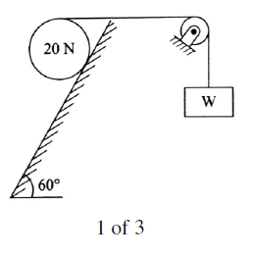
- Two blocks A and B are placed on inclined planes as shown in figure. The block A weighs 1000N. Determine minimum weight of the block B for maintaining the equilibrium of the system. Assume that the blocks are connected by an inextensible string passing over a frictionless pulley. Coefficient of friction μA between the block A and the plane is 0.25. Assume the same value for μB.
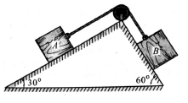
- Two blocks W1 and W2 resting on two inclined planes are connected by a horizontal bar AB as shown in figure. If W1 equals 1000N, determine the maximum value of W2 for which the equilibrium can exist. The angle of limiting friction is 200 at all rubbing faces.
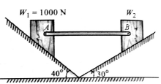

- A uniform ladder of weight 800N and of length 7 m rests on a horizontal ground and leans against a smooth vertical wall. The angle made by the ladder with the horizontal is 600. When a man of weight 600N stands on the ladder at a distance 4m from the top of the ladder, the ladder is at the point of sliding. Determine the coefficient of friction between the ladder and the floor
- A pull of 60 N inclined at 250 to the horizontal plane, is required just to move a body placed on a rough horizontal plane. But the push required to move the body is 75N. If the push is inclined at 250 to the horizontal, find the weight of the body and coefficient of friction.
- Figure-1 shows the coefficient of static friction is 0.25. Compute the value of the horizontal force ‘P’ necessary to (i) Just start the block up the incline. (ii) Just prevent motion down the incline. (iii) If P=400N, what is the amount and direction of the friction force?
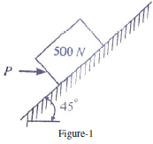
- Two blocks of weight W1 and W2 rest on a rough inclined plane and are connected by a short piece of string as shown in figure 1. If the coefficients of friction are μ1 = 0.2 and μ2 = 0.3, respectively, find the angle of inclination of the plane for which sliding will impend. Assume W1 = W2= 5 N.
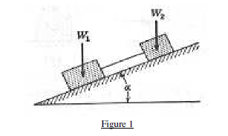
- Referring to figure1 the coefficient of the friction is as follows: 0.25 at the floor, 0.30 at the wall, and 0.20 between blocks. Find the minimum value of a horizontal force P applied to the lower block that will hold the system in equilibrium.
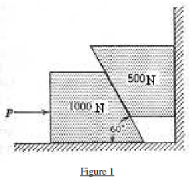
- Two blocks A and B are resting against a wall and the floor as shown in figure. Find the value of the horizontal force P applied to the lower block that will hold the system in equilibrium. Coefficients of frictions are 0.25 at the floor, 0.3 at the wall and 0.2 between the blocks
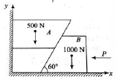
- On a ladder supported at A and B, as shown in the figure, a vertical load W can have any position as defined by the distance a from the bottom. Neglecting friction, determine the magnitude of the reaction at B. Neglect the weight of the ladder.

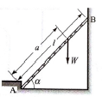
UNIT-3
- Determine the volume generated by rotating a semi-circular area of radius `r` about a non-intersecting axis using Pappus theorem.
- Determine the area generated by rotating a line of length `l` about x-axis from a distance `r` using Pappus theorem.
- Determine the centroid of a rectangle having base b and height h
- Derive the centroid of a circle
- Derive the centroid of a rectangle
- Derive the centroid of a semicircle
- Derive the centroid of a quarter circle
- Derive the centroid of a triangle
- Locate the centroid of the hatched area r=10cm as shown in the figure 4.
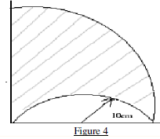
- Find the centroid of the hatched area shown in figure 4.
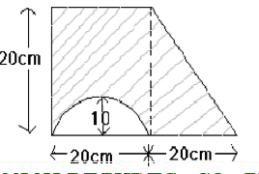

- Locate the centroid of the hatched area r=30mm as shown in the figure 3
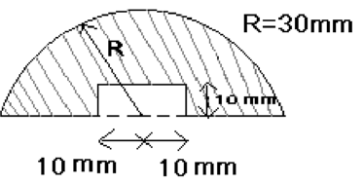
- Find the centroid of the following figure.
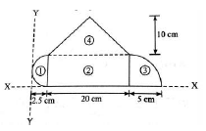
- For the T-section shown in figure, determine the moment of inertia of the section about the horizontal and vertical axes, passing through the centre of gravity of the section.
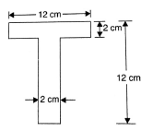
- Discuss the procedure to find the location of the centre of gravity of a composite body.
- For the I-section shown in figure, find the moment of inertia about the centroidal axis X-X perpendicular to the web.
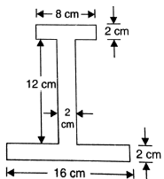
- Locate the centroid of an I-section about X-X axis as shown in the figure-3.
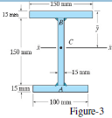
- Locate the Center of gravity of the area as shown in figure with respect to coordinate axes. All dimensions are in mm.
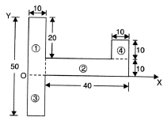
- State and prove Pappus theorems of area and volume.
- Find the centre of gravity of the Lsection shown in figure
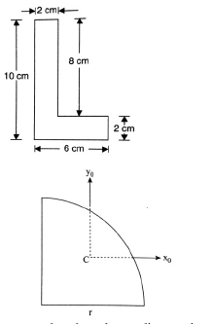
- Locate the centroid of the area bounded by the two coordinate axes and a circle of radius a with its centre at (0,a).
- State and prove Pappus theorems of area and volume
- Determine the distance of the centroid from the base of a triangle of altitude h.
- Locate the centroid of a circular sector of radius r and included angle 2 α, selecting the symmetrical radial line as the x-axis.
- A wire has been bent into the shape as shown in figure. Determine the position of the centroid of the wire.
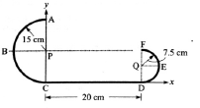
- A thin homogeneous wire is bent into a triangular shape ABC such that AB = 240mm, BC = 260mm and AC = 100mm. locate the Center of Gravity of the wire with respect to coordinate axes. Angle at A is right angle.
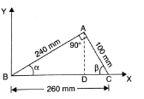
- Determine the centre of gravity of the following figure.
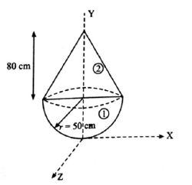
- Derive the formula for the mass moment of inertia rectangle with help of a suitable sket
- Derive the formula for the mass moment of inertia circle with help of a suitable sket
- Derive the formula for the mass moment of inertia semicircle with help of a suitable sket
- Derive the formula for the mass moment of inertia triangle with help of a suitable sket
- Derive the formula for the mass moment of inertia rectangle with help of a suitable sket
- Find the moment of inertia for the in the figure
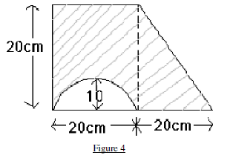
- Determine the mass moment of inertia of a cylinder shaft of 100mm diameter and 2.5m height above the center of gravity axes. (Density,ρ=8000kg/m3).
- Determine moment of inertia of given section about centroidal XX axis.
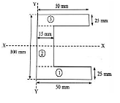
- Find moment of inertia values of circle of radius 25mm about its centroidal XX and YY axes
- Determine moment of inertia of a steel sphere 150mm diameter with respect to centre of gravity axes. Given density of steel as 7830 kg/m
- An isosceles triangle section ABC has a base of 100mm and 60mm height. Determine the moment of inertia of triangle about the centroid and about base
- Find the moment of inertia of an aluminum pipe of 150mm outer diameter and 120mm inner diameter and 3.5m height about its longitudinal axis YY.(density, _=2560 kg/m3).
- Determine the product of inertia Ixy of the area under the curve.
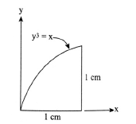
- Calculate the polar moment of inertia of the area shown in figure about point O.
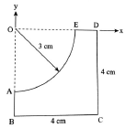
- Find the mass moment of inertia of a hollow cylinder about its axis. The mass of the cylinder is 5kg, inner radius 10cm, outer radius 15cm and height 20cm.
- Determine the product of inertia of a quarter-circular area about its centroidal axes which are parallel to its edges.
- State and derive transfer theorem for areas
- Find area moment of inertia of L section shown in Figure-4 about X axis.
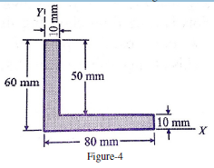
- Determine the product of inertia with respect to the x0 and y0 axes passing through the centroid.
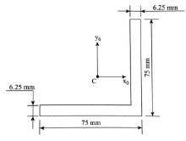
- An isosceles triangle section ABC has a base of 100mm and 60mm height. Determine the moment of inertia of triangle about the centroid and about base
- Derive the expression for the moment of inertia of a homogeneous right circular cone of mass m, base radius r and altitude h with respect to its geometric axis.
- Find the moment of inertia of the following figure about the given X-Xaxes.
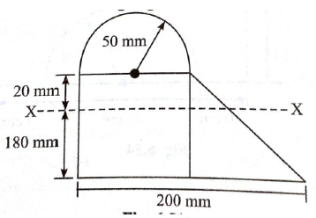
- State and prove transfer formula for product of inertia
- Find the mass moment of inertia of an aluminum pipe of 120mm outer diameter and 90mm inner diameter and 2.5m height about its longitudinal axis. (density,_=2560 kg/m3).
- Derive the mass moment of inertia of a right circular cone of base radius R, height H and mass M about its axis
- Derive the mass moment of inertia of a rectangular plate about a line passing through the base.

UNIT-4
- An elevator is moving upwards with a constant speed of 10m/s. If a man standing inside the elevator drops a coin from a height of 2.45m, find the time taken by the coin to reach the floor of the elevator. (g=9.8m/s2).
- A stone, dropped from a certain height, can reach the ground in 5s. It is stopped after 3 seconds of its fall and then allowed to fall again. Find the time taken by the stone to reach the ground for the remaining distance.
- A launcher fires a missile with a velocity of 60m/s at an angle with the horizontal If the missile lands 323m away at the same level, determine the angle of projection. Also find the corresponding time of flight and the maximum height attained by the missile.
- A motorist takes 10 seconds to cover a distance of 20m and 15 seconds to cover a distance of 40m. Find the uniform acceleration of the car and the velocity at the end of 15 seconds
- A stone is dropped into a well while splash is heard after 2.5 seconds. Then determine depth of water surface assuming the velocity of sound as 330 m/s.
- A stone is dropped into a well and the splash is heard after 3s. If the speed of sound in air is 340m/s, determine the depth of the well
- A stone, dropped from a certain height, can reach the ground in 5s. It is stopped after 3 seconds of its fall and then allowed to fall again. Find the time taken by the stone to reach the ground for the remaining distance.
- Two trains P and Q leave the same station on parallel lines. Train P starts at rest with uniform acceleration of 0.2 rad/s2 attains a speed of 10 m/s. Further the speed is kept constant. Train Q leaves 30 seconds later with uniform acceleration of 0.5 m/s2from rest and attains a maximum speed of 20 m/s, when will train Q overtake train P.
- A car covers 100m in 10 seconds, while accelerating uniformly at a rate of 1m/s2. Determine i) initial and final velocities of the car, ii) distance travelled before coming to this point assuming it started from rest, and iii) its velocity after the next 10 seconds.
- A ball is thrown vertically upwards from the ground with an initial velocity of 20m/s. Determine i) the maximum height reached by the ball, ii) the time taken to reach the maximum height, and iii) the total time of flight
- .A solid cylinder weighing 1300N is acted upon by a force P horizontally as shown in figure. Determine the maximum value of P for which there will be rolling without slipping (given μ=0.2).
    - 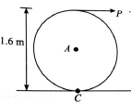
- The speed of a truck moving at a constant speed of 30 m/s is reduced to 20 m/s in a distance of 200 m. Determine i) the acceleration assuming to be constant, and ii) the time taken to a stop with the acceleration calculated in part (i).
  - 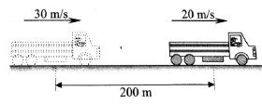
- An elevator weighing 6 tons together with the passengers descends with a speed of 4m/s. If the tension in the cable must not exceed 50kN, what is the shortest distance in which the elevator can be stopped?
- . Two bodies start moving in the same straight line at the same instant of time from the same origin. The first body moves with a constant velocity of 40m/s, and the second starts from rest with constant acceleration of 4m/s2. Find the time elapses before the second catches the first body. Also, find the greatest distance between them prior to it and the time at which this occurs.
- A particle undergoing central force motion has a tangential velocity of 20m/s while at a distance of 300m from the central point. Using the fact that the areal velocity of the particle must be constant, find its tangential velocity when it is 400m away from central point.
- A vehicle running at 36km/h on a straight road accelerates uniformly to 72km/h over a distance of 200m. Determine the acceleration and time taken. How much distance will be covered by the vehicle in the 5th second?

UNIT-5

- A beam AB of span 5 metres is carrying a point load of 2 kN at a distance 2 metres from A. Determine the beam reactions, by using the principle of the virtual work.
- Two beams AC and CD of length 9 m and 10 m respectively are hinged at C. These are supported on rollers at the left and right ends (A and D). A hinged support is provided at B, 7m from A as shown in Fig. 16.4. Using the principle of virtual work, determine the force transmitted by the hinge C and the reaction at the support B, when a load of 700 N acts at a point 6 m from D.
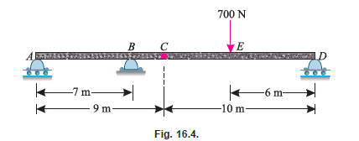

- Two beams AE and BD are supported on rollers at B and C as shown in Determine the reactions at the rollers B and C, using the method of virtual work
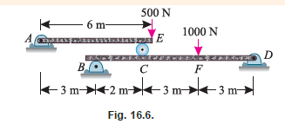
- A simply supported beam AB of span 4 m is subjected to a point load of 10 kN at a distance of 1.5 m from A. Using the principle of virtual work, determine the reactions at the two supports.
- Two beams AD and DF of spans 6m and 4m respectively are hinged at C and supported at A, D and F. The beams are loaded as shown in Fig. 16.13. Using the principle of virtual work, find the reaction at D.
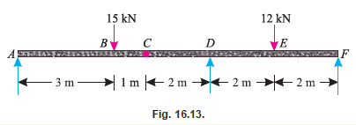
- A 10.0 kg mass sliding on a frictionless horizontal surface at 7.00 m/s hits a spring that is attached to a wall. The spring has a spring constant of 5000 N/m.
a) Determine the maximum compression of the spring.
b) Determine the speed of the box in the above problem when the spring had a compression of 0.100 m.
c) Suppose the box springs back off of the spring with no loss of energy, after sliding on the frictionless surface, it encounters another level surface with a coefficient of friction of 0.200. How far does the box slide on this surface before coming to rest?
- A 6.00 kg mass is acted on by a net force shown in the graph above. a) if the object started from rest, what is its velocity after it has moved 10.0 m? b) If the object in initially was moving at 5.00 m/s in the direction of the net force, what was its speed after it had moved a distance of 6.00 m?
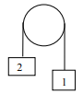
- In the diagram above the pulley is frictionless. Mass 1 is 3.00 kg and mass 2 is 7.00 kg, and the two masses are released from rest. After the two masses have each moved 0.500 m, what are their velocities?
- ) A mass is dropped from a height of 4.00 m onto a spring with a spring constant of 120 N/m. If the spring compresses by a maximum amount of 1.25 m, what is the mass of the object?
- What was the speed of the mass in the above problem when the spring was compressed a distance of 0.500 m?
- A 10.0 kg mass is dropped from a tall building. During the first second of the fall, what was the average power exerted by gravity? What was the average power exerted by gravity during the first 5.00 seconds of the fall?
- A 2.0 kg box slides down a frictionless incline as shown above. Determine the following: As the box slides, determine the amount of work done by:
- the incline (normal force)
- Gravity
- What is the net work done on the box as it slides?
- What is the final kinetic energy of the box (at the bottom of the incline)?
- What is the final velocity of the box at the bottom of the incline?

- In the diagram below, the spring has a force constant of 5000 N/m, the block has a mass of 6.20 kg, and the height h of the hill is 5.25 m. Determine the compression of the spring such that the block just makes it to the top of the hill. Assume that there are no non­conservative forces involved.
- 8 What average force F is necessary to stop a 16 g bullet traveling at 260 m/s as it penetrates into wood at a distance of 12 cm?
- A 1200kg car is traveling at 18m/s when it applies its brakes. If the brakes allow friction to exert a 2000N force on the car, and the brakes are applied for 50m, how fast is the car moving when the brakes are released?
- A 2-kg object is being pushed by a horizontal force F along a horizontal frictionless air-table. The object starts from rest at x = 0 and the force F acting on it changes according to the force F v.s. position x graph to the right. a) Find the work done by the force F on the object as the object moves from x=0 to x=9m. b) Find the speed of the object at x = 9 m.
